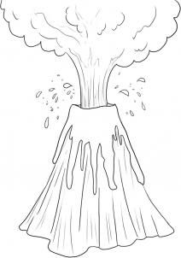
How Can I Stop My Volcano From Erupting

